EXPERIMENT 2
clc; clear; close all;
Am = 1; fm = 500; Ac = 5; fc = 5000; fs = 20*fc; t = 0:1/fs:4/fm;
m = Amsin(2pifmt); c = Acsin(2pifct); mu = Am/Ac;
am = Ac*(1+musin(2pifmt)).sin(2pifct);
dem = abs(hilbert(am)); dem = dem - mean(dem); N = length(am); f = linspace(-fs/2, fs/2, N); AM_FFT = abs(fftshift(fft(am)))/N;
USB = fc + fm; LSB = fc - fm; Pc = Ac^2/2; Psb = (mu^2*Pc)/4;
figure('Name','AM Modulation','NumberTitle','off'); subplot(3,2,1); plot(t,m); title('Message'); grid on;
subplot(3,2,2); plot(t,c); title('Carrier'); grid on; subplot(3,2,3); plot(t,am); title('AM Signal'); grid on; subplot(3,2,4); plot(t,dem); title('Demodulated'); grid on;
subplot(3,2,5); plot(f,AM_FFT); xlim([fc-3fm fc+3fm]); title('Sidebands'); grid on;
subplot(3,2,6); bar([Pc Psb Psb]); set(gca,'XTickLabel',{'Carrier','USB','LSB'}); title('Power'); grid on;

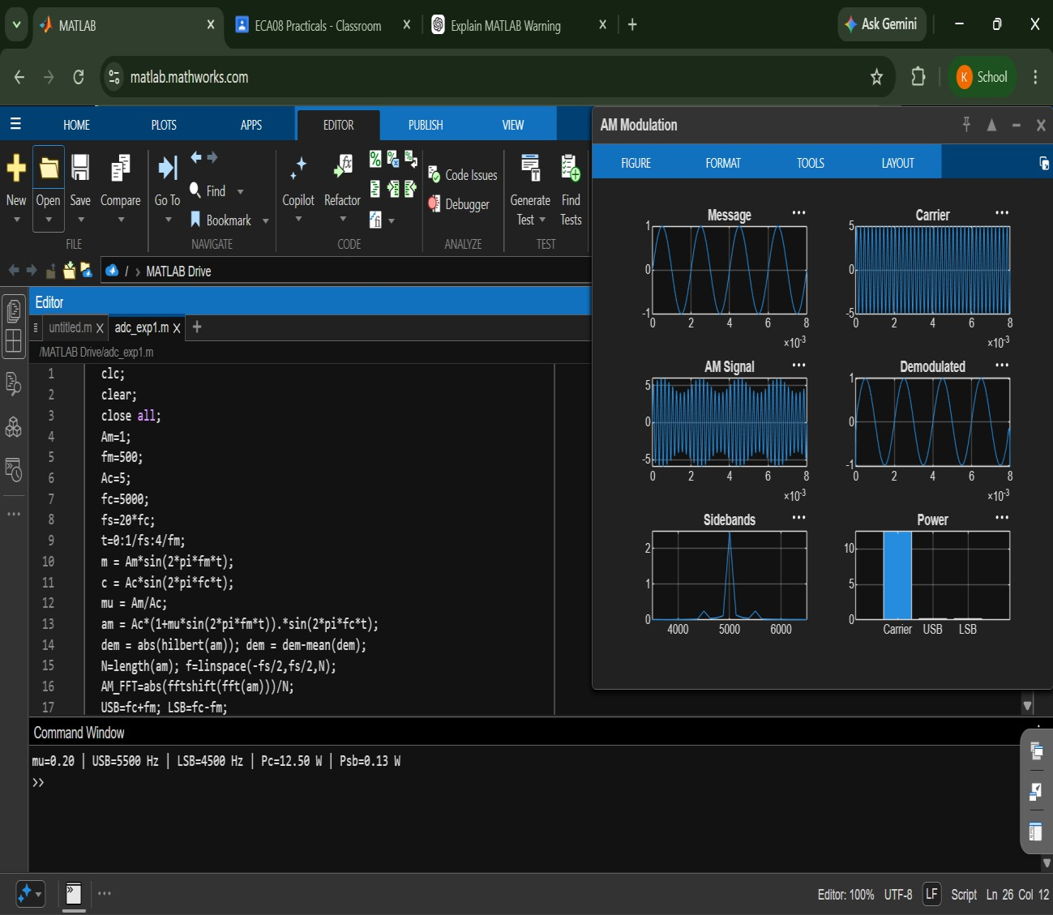
fprintf('mu = %.2f | USB = %d Hz | LSB = %d Hz | Pc = %.2f W | Psb = %.3f W\n', ... mu, USB, LSB, Pc, Psb);

